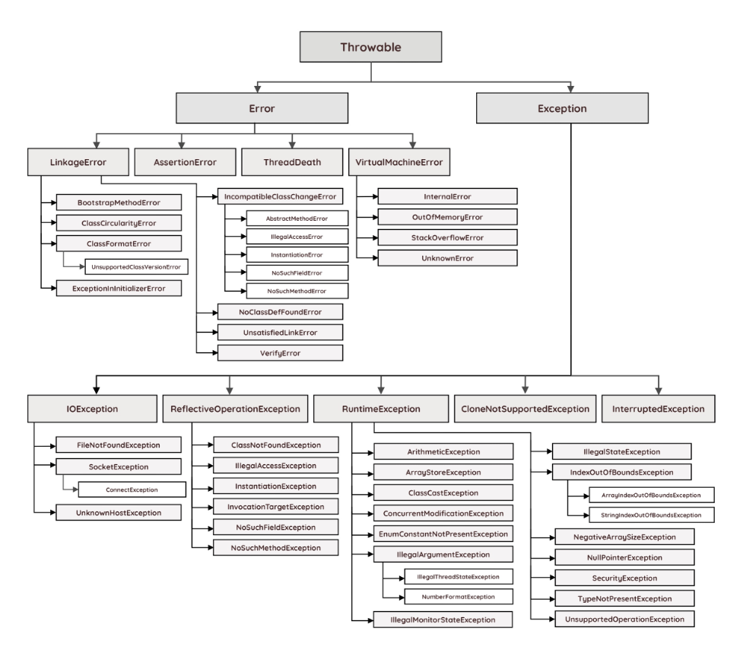
LinkageError
Error
Throwable
AssertionError
ThreadDeath
VirtualMachineError
BootstrapMethodError
ClassCircularityError
ClassFormatError
UnsupportedClassVersionError
IncompatibleClassChangeError
AbstractMethodError
IllegalAccessError
InstantiationError
NoSuchFieldError
InternalError
OutOfMemoryError
StackOverflowError
UnknownError
ExceptionInInitializerError
IOException
NoSuchMethodError
NoClassDefFoundError
UnsatisfiedLinkError
VerifyError
ReflectiveOperationException
RuntimeException
Exception
CloneNotSupportedException
InterruptedException
FileNotFoundException
ClassNotFoundException
ArithmeticException
SocketException
IllegalAccessException
ArrayStoreException
IllegalStateException
IndexOutOfBoundsException
ConnectException
InstantiationException
ClassCastException
ArrayIndexOutOfBoundsException
UnknownHostException
InvocationTargetException NoSuchFieldException NoSuchMethodException
ConcurrentModificationException
StringIndexOutOfBoundsException
EnumConstantNotPresentException
NegativeArraySizeException
IllegalArgumentException
IllegalThreadStateException
NumberFormatException
IllegalMonitorStateException
NullPointerException
SecurityException
TypeNotPresentException
UnsupportedOperationException

